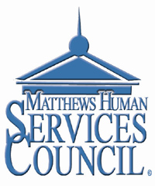

Dear Non-Profit Representative,
Have you ever wanted to share ideas with other non-profit organizations? To hear what has worked for them and share your successes? We have a group in Matthews that does just that for its members!
The Matthews Human Services Council meets at noon every 4th Tuesday of the month for the purpose of sharing ideas and gaining helpful information. At this time, you may distribute brochures or other materials with information about your non-profit organization.
If you are affiliated with a non-profit, please give us a try. The council meets during the months of January through May, taking the summer months off, and then meeting again September through December. The meetings are held at the Levine Senior Center where lunch is available at a minimal cost. This is a time of fellowship and sharing what we do in our different organizations and how we can help each other. We share our upcoming events and projects and compare calendars.
Please check out the website at www.matthewshsc.org and let me know if you would like to attend one of our upcoming meetings.
If you are interested in joining the Matthews Human Services Council, please fill out the attached application and mail it with the fee of $25 to the address below.
Thank you and we look forward to working with you in the future.
Sincerely,

Bill Helms
President
Human Services Council
PO Box 2953
Matthews, NC 28106
billhelms@carolina.rr.com

Matthews Human Services Council
Membership Application

Name of Organization:___________________________________________________________
Contact Name:_________________________________________________________________
Address:_______________________________________________________________________
_______________________________________________________________________
Phone: _______________________
Email: _______________________________________________________
Date Joined:___________________
Dues: $25.00 (check-made out to the Matthews Human Services Council or cash)

